**Homework 2 (Due: Sep 25)**

**Instructions**

* Complete the following questions to the best of your ability.
* Answers should be clear, concise, and justified with work.
* Hand-drawn circuits will not be accepted due to the confusion they might cause.
  + Use software, such as Logisim, to draw them.
* Please write your name and NetID on the hardcopy of your solution, and bring it to the lecture on the due day. Please submit your solution before the lecture starts.

# **Collaboration**

* Professor/TAs
  + You **may** discuss any content with any professor or TA.
* Students
  + You **may** discuss high-level concepts, techniques, jargon, keywords, related problems, or course content that is relevant to the material.
  + You **may not** discuss particular solutions to any of the questions.
  + If you have substantial conversations with any students, please note their name and, if you feel it necessary, the extent of your collaboration.
* Outside Sources (Internet, books)
  + You **may** use external references for any course content.
  + You **may** use an external tool to verify your solutions where appropriate, but not to generate solutions to any questions.
  + List any outside sources that you use. Formal citations are not necessary; links are fine.

# 

# **Question 1 (25 points)**

You have a D latch and a positive-edge-triggered D flip flop wired to the same data and clock inputs shown below. Assume that both are initially set to zero. Draw their respective outputs on the diagram. Note that you should fill out a total of 8 time slots for each output.

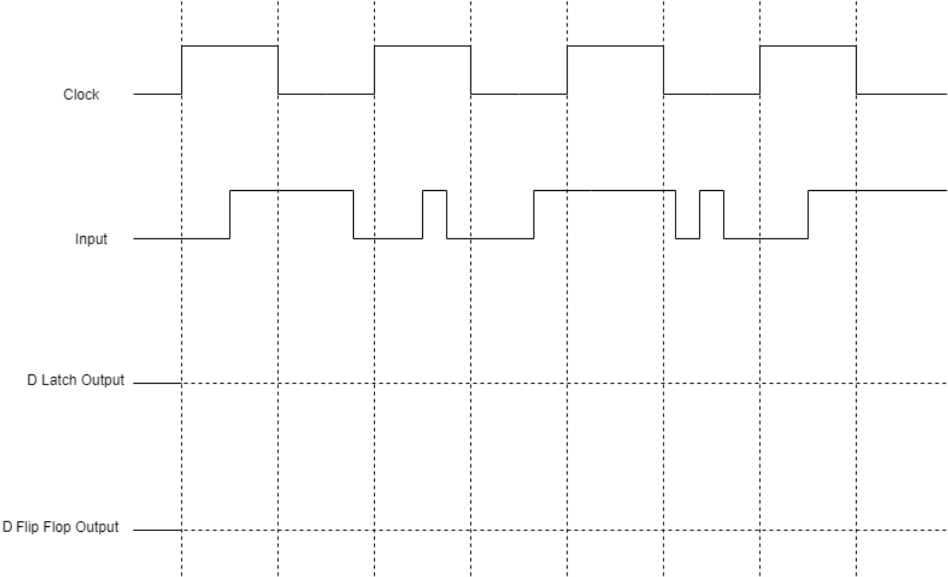

# **Question 2 (25 points)**

In this question you will try to explain why it is bad to set both S and R in an SR-latch to 1. To do so, discuss what happens when SR = 11 then SR = 00 afterwards. How will the SR-latch behave in this case and why is this bad?

# **Question 3 (50 points)**

Design a simplified traffic-light controller that switches traffic lights on a crossroads (north-south direction intersects with east-west direction). When a traffic light signal is ‘1’, the green light is on; otherwise, when the signal is ‘0’, the red light is on. The lights alternate every one minute. Assume east-west direction starts at green first. There is also a “Walk” signal that pedestrians can activate. If this signal is activated, the next time the traffic lights alternate they would both stay red for one additional minute, and then they continue their normal operation. Assume that pressing the “Walk” button has no effect if both lights are red.

1. Draw the Moore state diagram of the described FSM.
2. Derive the state table.
3. Derive the excitation table.
4. Write the equations for the next-state and output bits and minimize them.
5. Draw a schematic diagram for the FSM circuit using DFFs.